**Spartans Sporting Goods**

**PROJECT REPORT**

**MSIS 2621: Business Intelligence and Data Warehousing**



**Guided by:**

**Professor Sreeram Chavali**

**Submitted By:**

**Ramya Mamidipaka**

**Jai Ambekar**

**Mukesh Ganesh**

**Table of Contents**

Introduction 3

**System Benefits** 3

**Key features of sports equipment management software** 3

**Mind Map** 3

Part-1 Business Analysis 4

**Scenario** 4

**Parsing Scenario to Identify key Information** 4

**Business Data** 4

**Swimlane Diagram** 5

**Interpreting the Tasks and Goals** 5

**Analytical Measures** 6

**Lead Measures** 6

**Lag Measures** 6

**Descriptive Analytics** 6

**Predictive Analytics** 7

**Business questions** 7

Part- 2 Data Model Design 8

**OLTP Schema** 8

**ODS Schema:** 8

**OLAP Schema** 9

Part- 3 ETL Implementation 10

**Part 1: Extracting data from different data sources:** 11

**Part 2: Load data from ODS Tables to Dimension Tables** 16

Part- 4 Tableau Implementation 22

**Dashboard 1 - Lag Measures:** 22

**Dashboard 2 - Lead Measures:** 23

**Dashboard 3 - Descriptive Analysis:** 23

**Dashboard 4 – Predictive Analysis:** 24

Conclusion 24

# Introduction

Spartan Sporting goods management system ties together the use **point of sale** (POS) coupled to a powerful **inventory management** engine in addition to a fully integrated, real-time **accounting system** which automatically makes postings as we complete **day-to-day transactions.**

Technology in maintaining sporting goods enables managers to keep everything organized. By having quick access to data on the database, improved response time for customer queries, optimized order tracking technique and equipment maintenance with which managers can enhance daily sports activities for improved performance.

## **System Benefits**

1. Eliminate manual work errors
2. Benefit from real-time insights
3. Enforce security
4. Reduce Report Generation time
5. Seamless Customer Experience

## **Key features of sports equipment management software**

1. Sales Management
2. Inventory management
3. Payments Processing
4. Customer Support
5. Staff Management
6. Maintenance Scheduling

## **Diagram, letter Description automatically generatedMind Map**

# Part-1 Business Analysis

The Business Scenario here includes the details Spartan Sporting goods management, the process and operation flow, swim lane diagram.

## **Scenario**

A **Customer** enters the store to buy a new pair of shoes and tennis racket to start with a new hobby. The **Salesman** guides him through the aisles and assists him with the correct fit and model for the shoes. The Customer navigates through the store and finally gets his fit and size for shoes. Satisfied with the shoes, Customer now proceeds towards the tennis racket rack and seeks the help of Salesman for a racket for beginners. Salesman has a dialog with the customer regarding requirements for the racket types or any parameters the customer is looking for. Then Salesman shows him the existing rackets in different price ranges and according to the parameters of the customer, which are best suitable for beginners. Customer chooses his pick and proceeds towards payment. Salesman informs the **Inventory clerk** about the customer's pick and the Inventory clerk replaces the purchased items in the rack. The **Cashier** hands over the goods and receipt to the Customer. The receipt contains the bill amount for the order along with the prices for each item and the tax applied. The Customer then selects his Feedback on the screen based on his experience at the store.

## **Parsing Scenario to Identify key Information**

* **Stakeholders**: Customer, Salesman, Inventory Clerk, Cashier
* **Products**: Shoes, Tennis Racket
* **Infrastructure**: Scanner, Computer, Card Reader, Receipt Printer

## **Business Data**

|  |  |  |
| --- | --- | --- |
| **Type of Data** | **Entity** | **Data** |
| Business Data | Order Receipt | Sale Summary  Sale Item Details  Sale Amount  Store Detail |
| Inventory Data | Inventory Checklist | Items Purchased Sale Summary |

## **Swimlane Diagram**

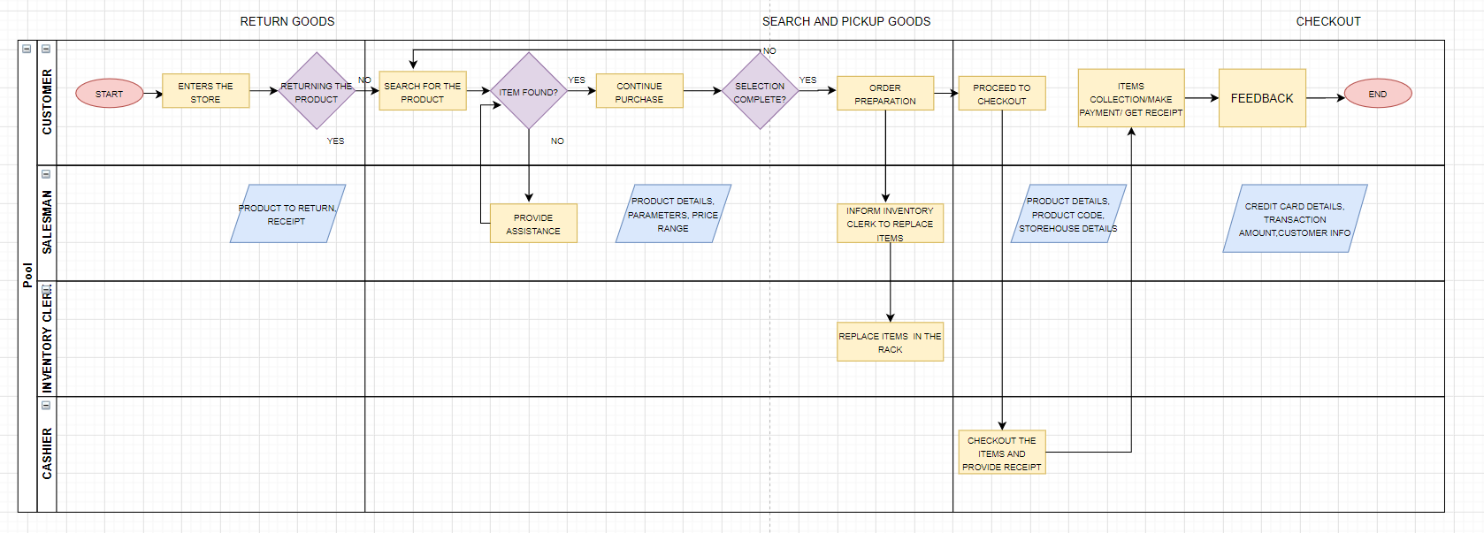

## **Interpreting the Tasks and Goals**

|  |  |  |
| --- | --- | --- |
|  | **Customer** | **Staff** |
| **Tasks** | |  |  | | --- | --- | | * Enter Store * Look for items * Ask for items * Pick up items * Proceed to checkout counter * Swipe credit card (pay cash) * Take Receipt * Exit store * Leave in car |  | |  | | | * Welcome the Customer * Help them through the racks * Guide them the best product according to their use * Explain the loyalty programs and offers * Proceed through the checkout process * Receive the feedback from the customer |
| **Goals** | Get the best product for the most reasonable price | Enable smooth experience through the process to get the customers visit the store again |

## **Analytical Measures**

## **Lead Measures**

1. Number of items in an order
2. Total orders in a day
3. Number of New customers daily
4. Inventory at the end of Day
5. Feedback score at the end of the end
6. Peak business hours for each day
7. New Customers signing up for the loyalty program Daily

## **Lag Measures**

1. Profit for the Quarter/Year
2. Frequent Customers
3. Most sold items in each category of goods every quarter/year
4. Price Dynamics based on the Orders/ Market
5. ROI/ Revenue growth
6. Expenses/ Costs incurred in a Quarter/Year
7. Stock for the coming season
8. How well was the Loyalty program received by the customers
9. Goods returned the most

## **Descriptive Analytics**

This is a reflective analysis of user data and is meant to provide insight into historical patterns of behaviors and performance in online learning environments. Descriptive analytics is leveraged when a business needs to understand the overall performance of the company at an aggregate level and describe the various aspects.

1. Trends of revenue in the total fiscal year
2. Comparing sales for the past years
3. Determining the most common payment type(cash/debit/credit)
4. Most bought goods for the customers for each region
5. Validate if a promotional campaign was successful or not
6. Customer Clusters for the promotions
7. Sales across various branches
8. Goods which were out of stock the most
9. Reviews

## **Predictive Analytics**

The subsequent step in data reduction is predictive analytics. Analyzing past data patterns and trends can accurately inform a business about what could happen in the future. This helps in setting realistic goals for the business, effective planning and restraining expectations. Predictive analytics is used by businesses to study the data and ogle into the crystal ball to find answers to the question “What could happen in the future based on previous trends and patterns?”. This is mainly undertaken to gather data on customers and predict next actions based on historical behavior.

1. Improving operations to better manage inventory and other resources
2. To set prices based on things like seasonality
3. Launch promotions that better targeted your customers
4. Introducing new goods into the chain based on inputs from the market

## **Business questions**

1. How many transactions are made per day/month/year?
2. What is the average sale per transaction?
3. Which product/item is the most trending in the store?
4. What is the peak time at the store?
5. What is the maximum/minimum total bill amount for day/month/year?
6. Which were the category products that were sold the most/least?
7. What is the frequency of customers which came to the store?
8. Are the items on sale being purchased more by customers?
9. What percentage of customers are returning orders?
10. Which item/category are returned the most?
11. How many transactions were made by Credit Card/Debit Card?

# Part- 2 Data Model Design

## **OLTP Schema**

The OLTP schema is designed in ERWIN to have 6 tables Orders, Payment, Order line, Store, Customer, Product.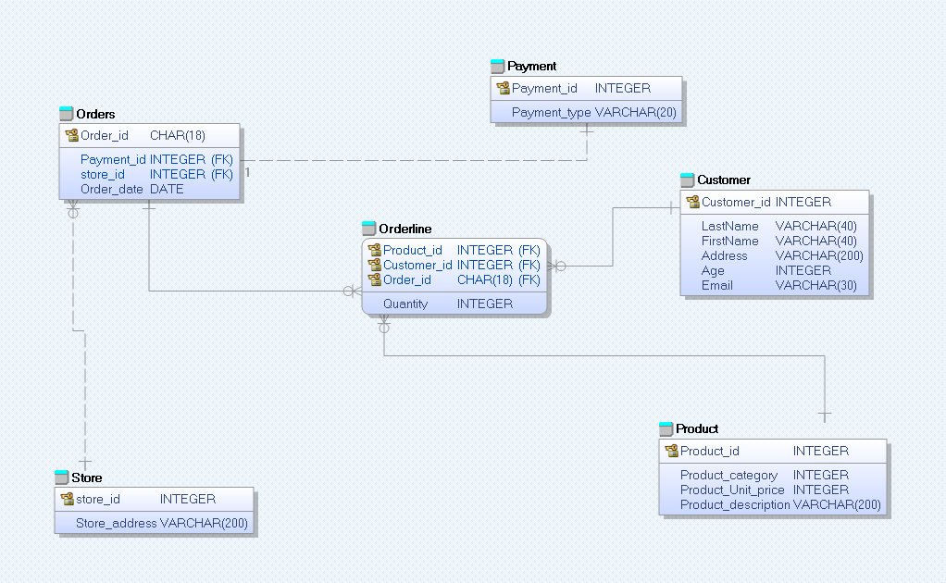

## **ODS Schema:**

It is an interim area for a data warehouse sitting between the data sources and the data warehouse. An ODS deals exclusively with current operational data and basic status-level reporting, because an ODS continuously overwrites data. Here we merged Store details, payment, order line details into order tableDiagram

## **OLAP Schema**

Designed the OLAP schema for the Spartans sports management in ERWIN. There are five Dimension tables and one fact table. The Dimension tables are:

Customer

Date

Store

Product

Orders

# Part- 3 ETL Implementation

**Data Sources used for implementation:**

1. MySQL Database

2. Json

3. CSV

4. Excel

**Data Sets:** Data are manually generated from generatedata.com

**Website:** Generatedata.com

**Procedure Followed**

* + - 1. Loaded the data from multiple sources mentioned above into the spartans_gamestore database
      2. Created a staging denormalized schema from the OLTP database
      3. Created dimension table from the database with Surrogate keys
      4. Loaded the dimension tables into spartans_gamestore_dw database
      5. And then loaded the Fact table into the DW database

**Denormalized Table: Staging Denormalized Schema**

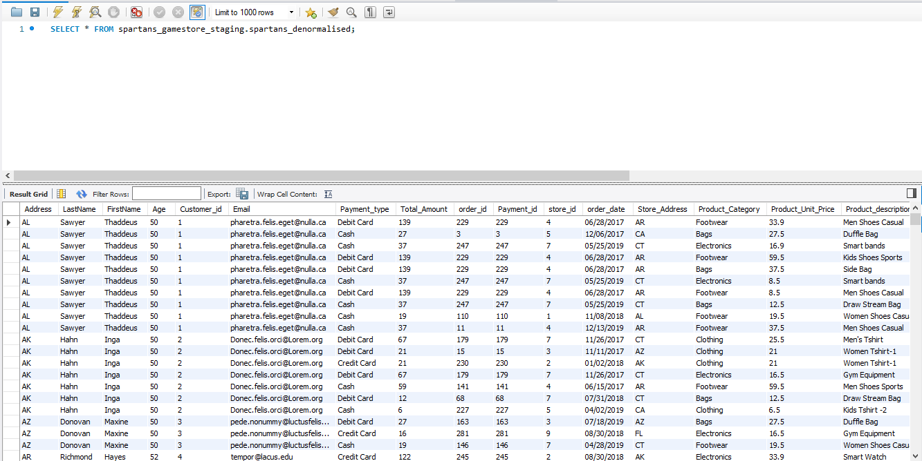

## **Part 1: Extracting data from different data sources:** This is Phase 1 of ETL transformations, where we extracted data from various data sources and stored it in MySQL DB using **Pentaho**

1. Customers data: Excel file to Database

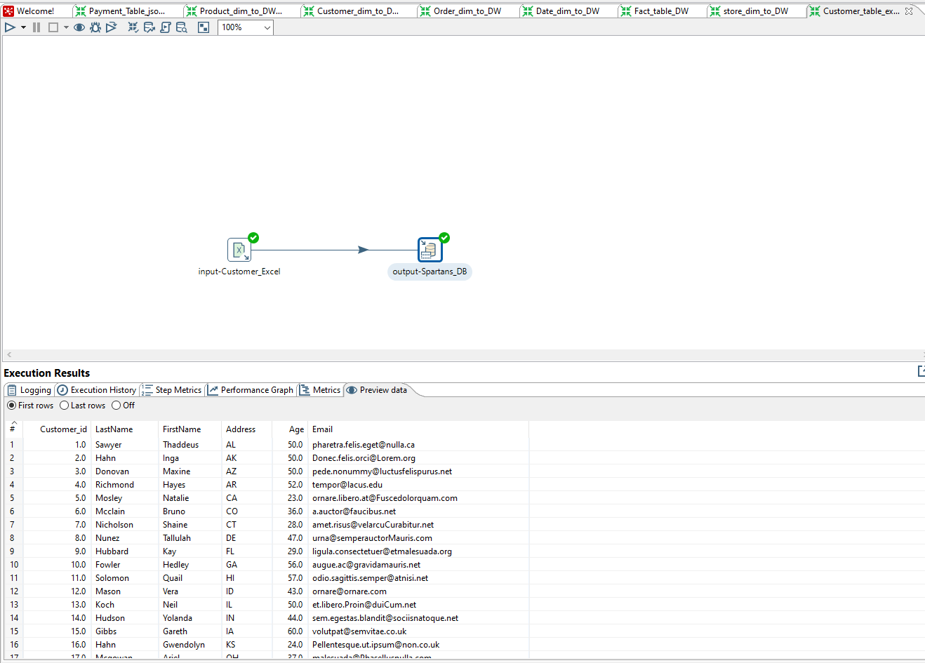

Mysql Results

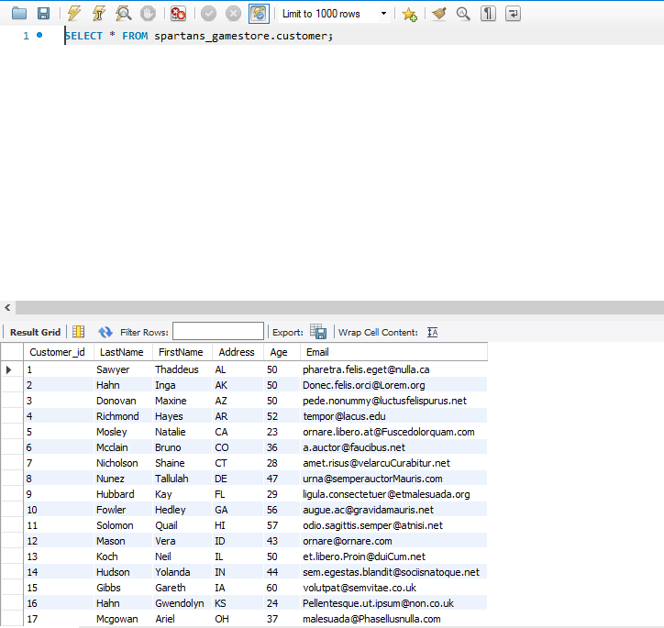

1. Order line data: Excel file to Database

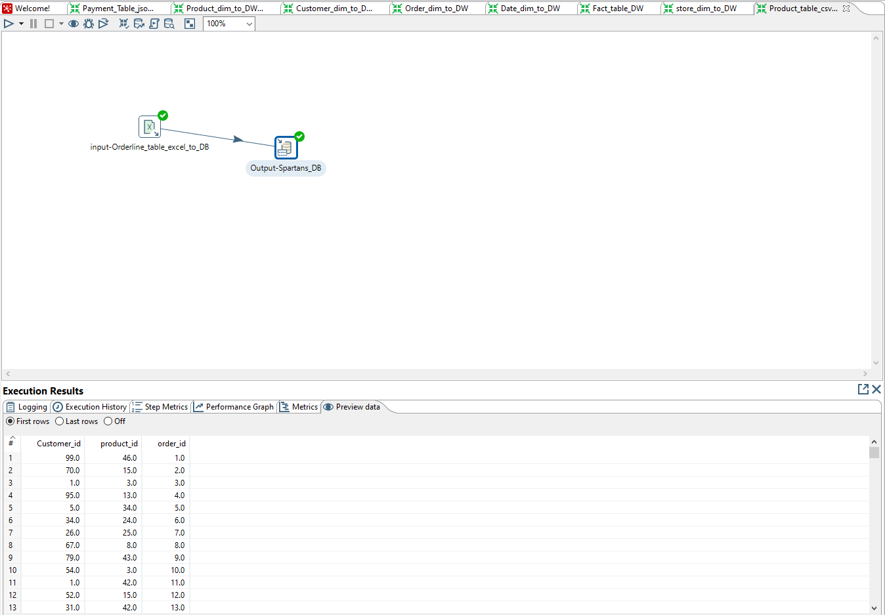

Mysql Results

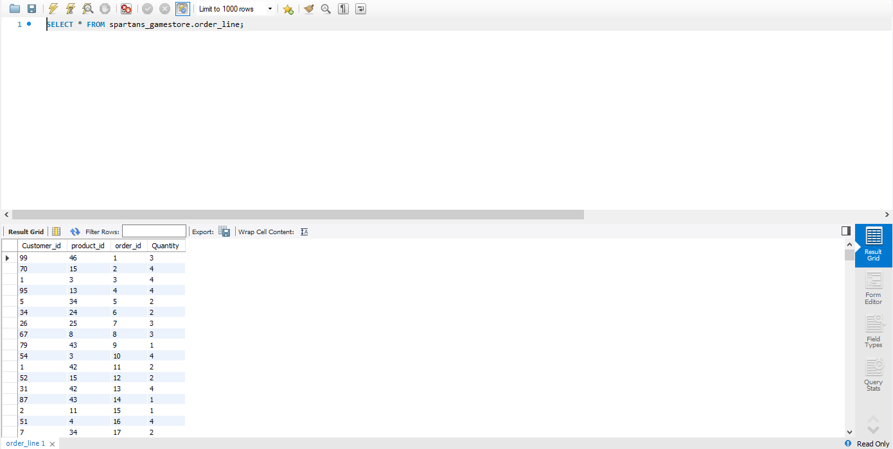

1. Payment data: Json file to Database

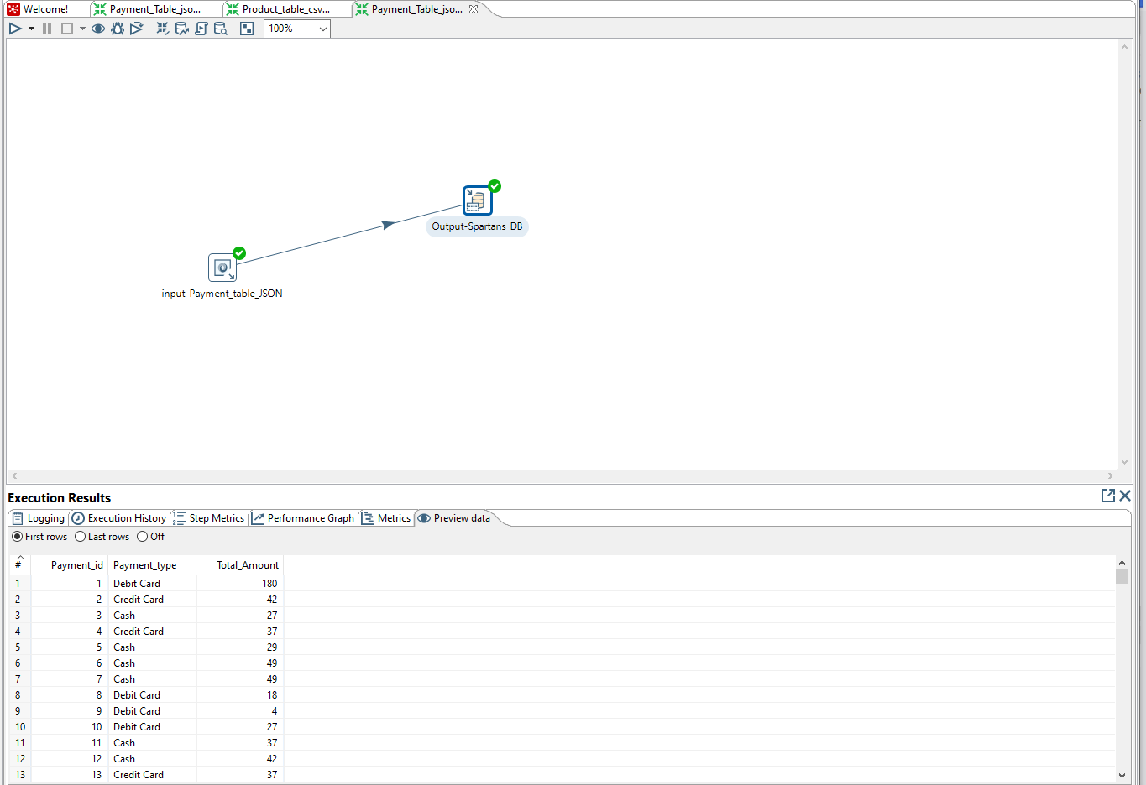

Mysql Results

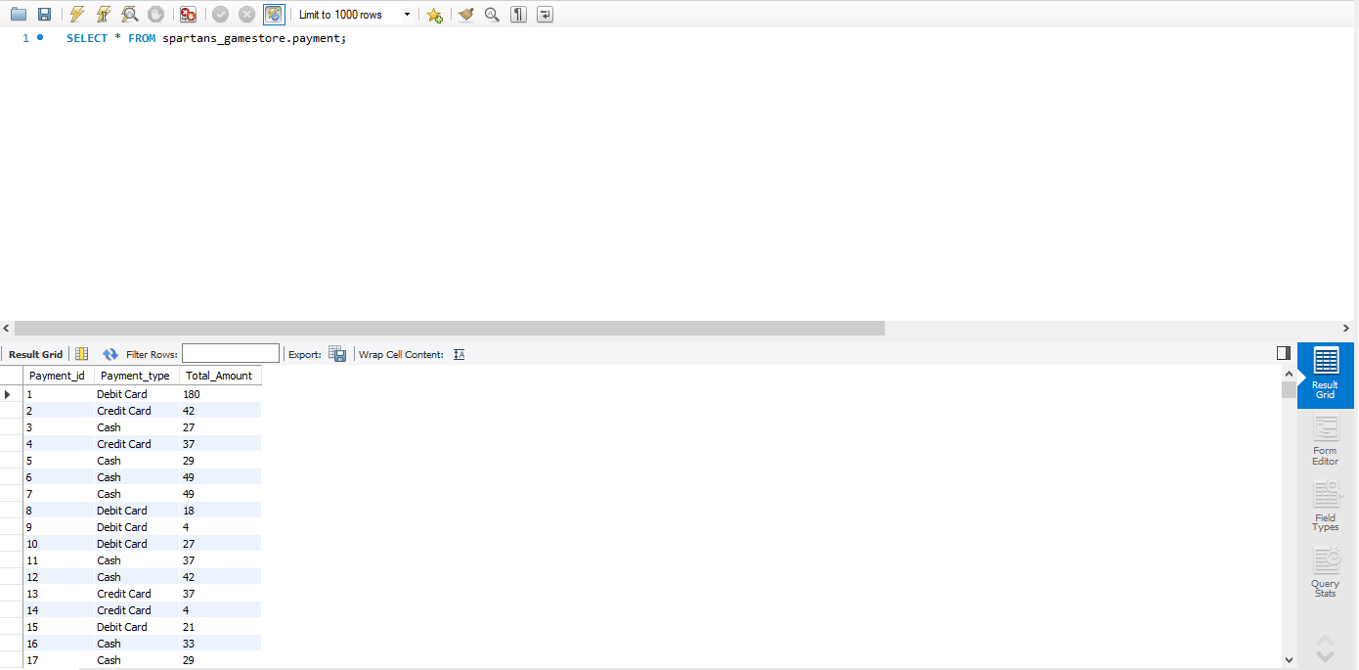

1. Product data: CSV file to Database

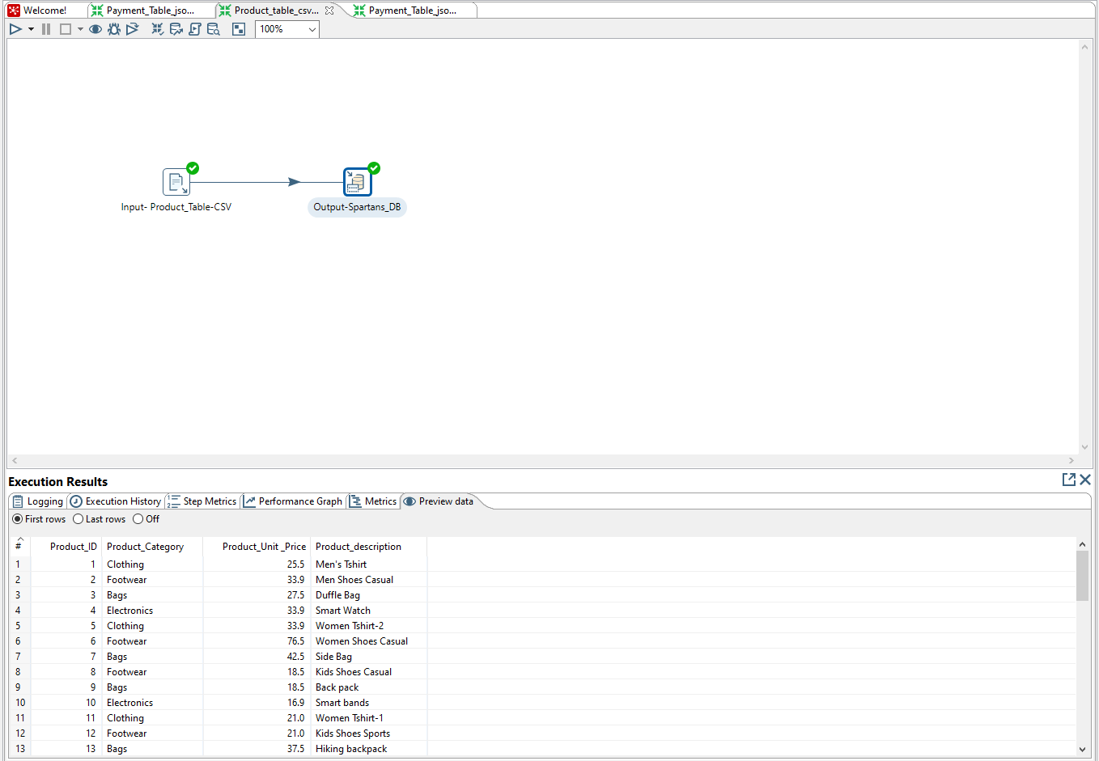

Mysql Results

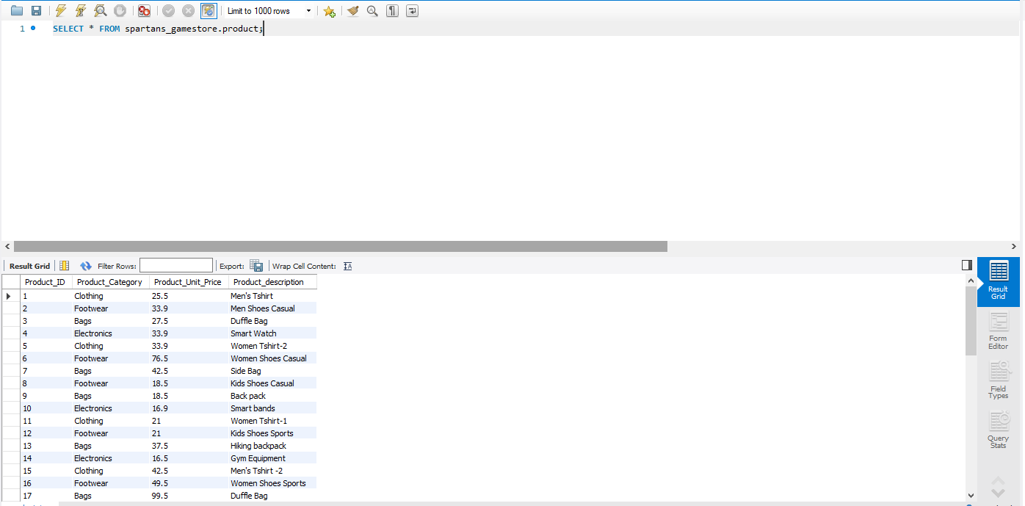

1. Stores data: Excel file to Database

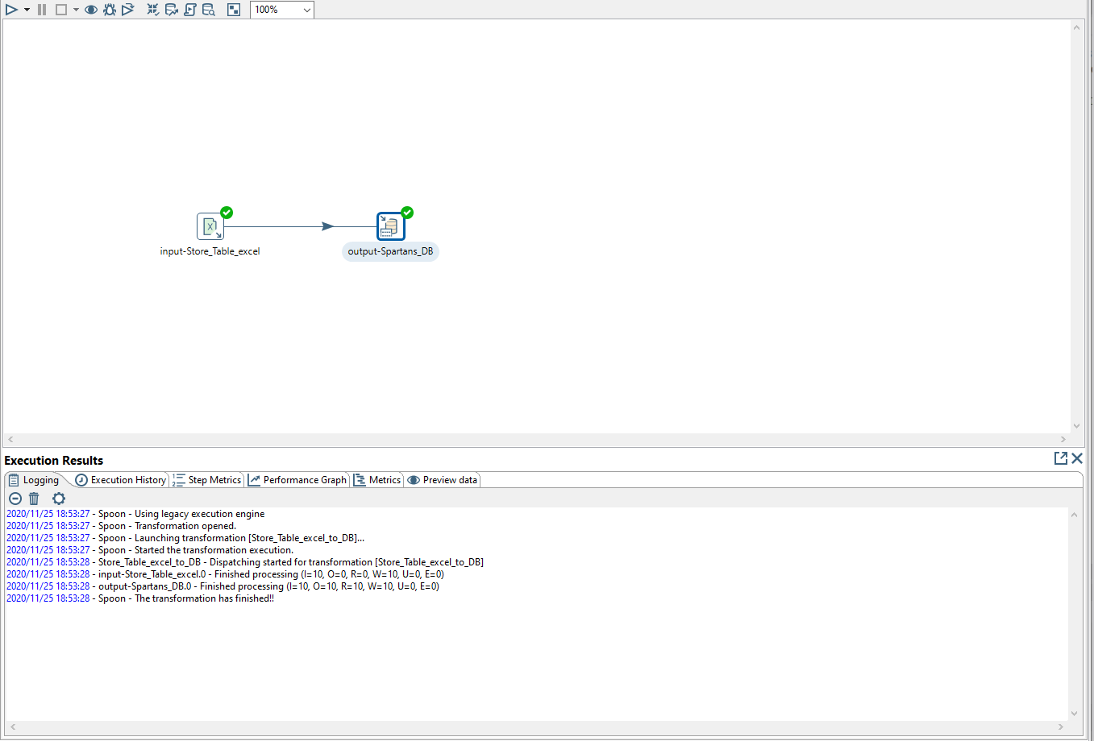

Mysql Results

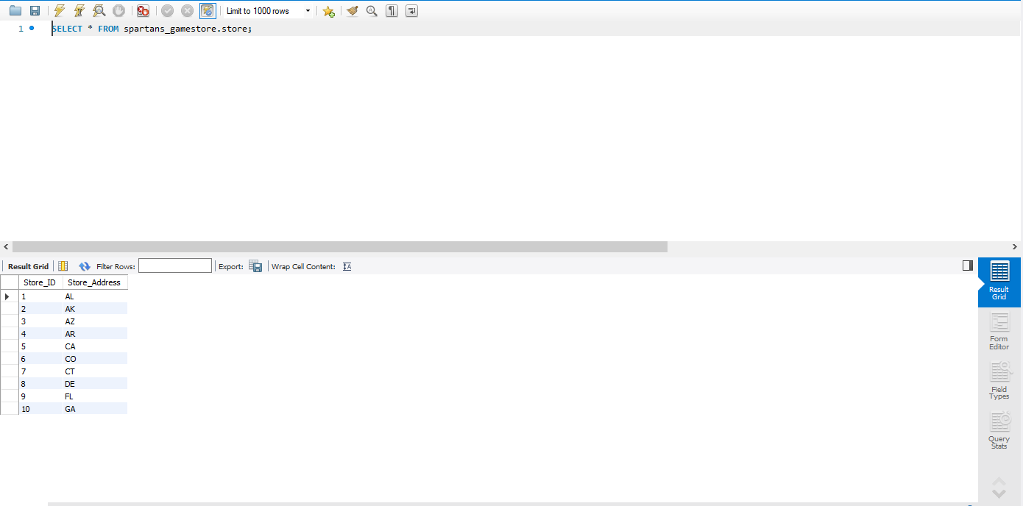

## **Part 2: Load data from ODS Tables to Dimension Tables** In Phase 2 of ETL Transformations, we created Staging schema from all the input tables and then we loaded data in dimensions tables and the fact table using pentaho.

Customer dimension data to Data Warehouse

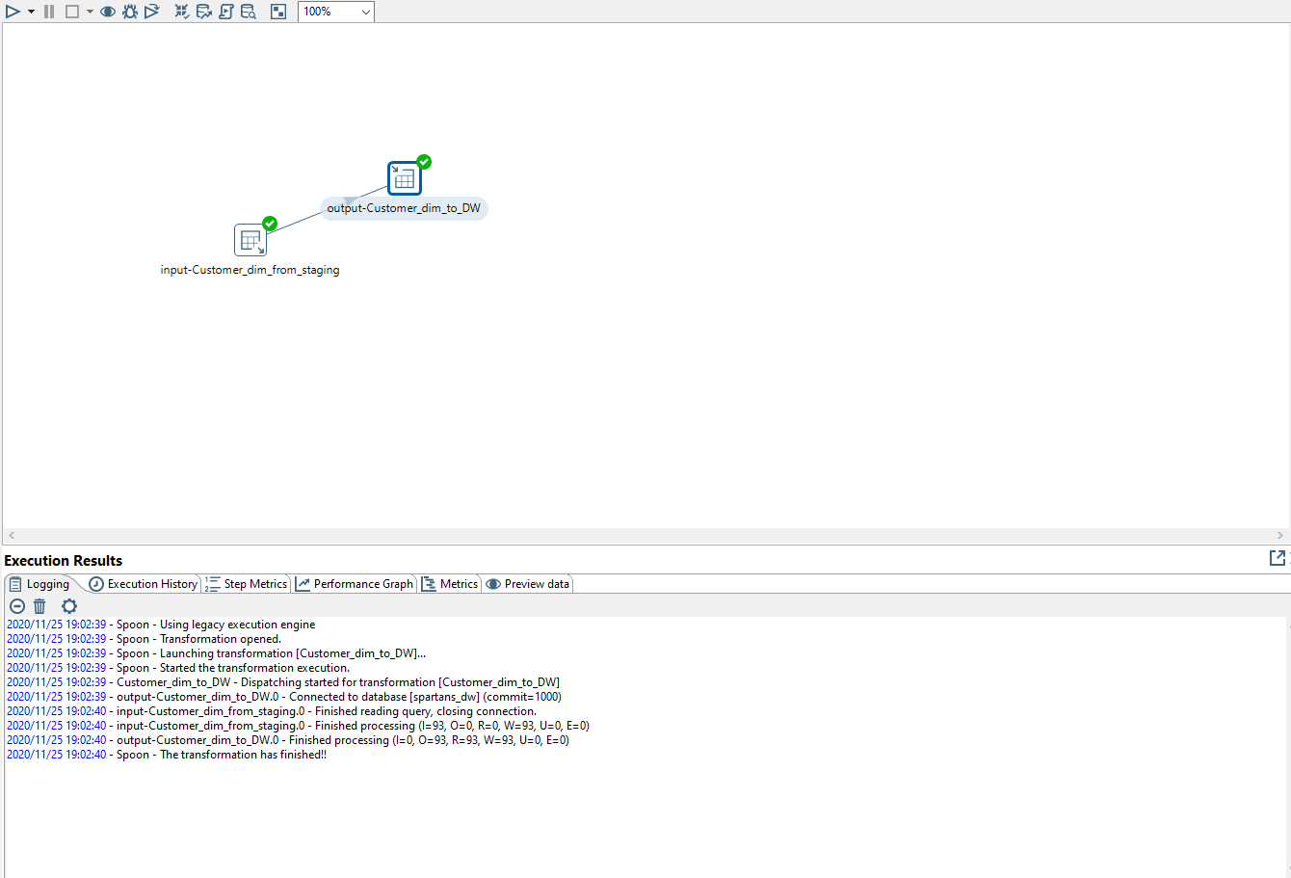

Mysql Results

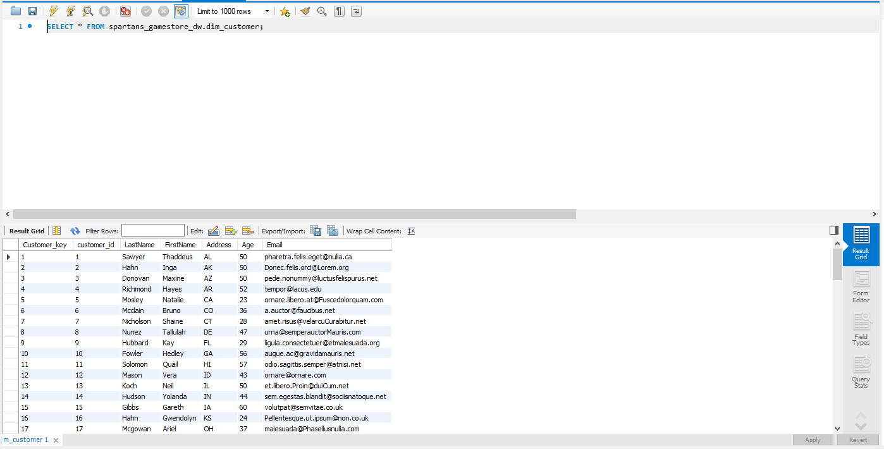

Date dimension data from excel to Data Warehouse

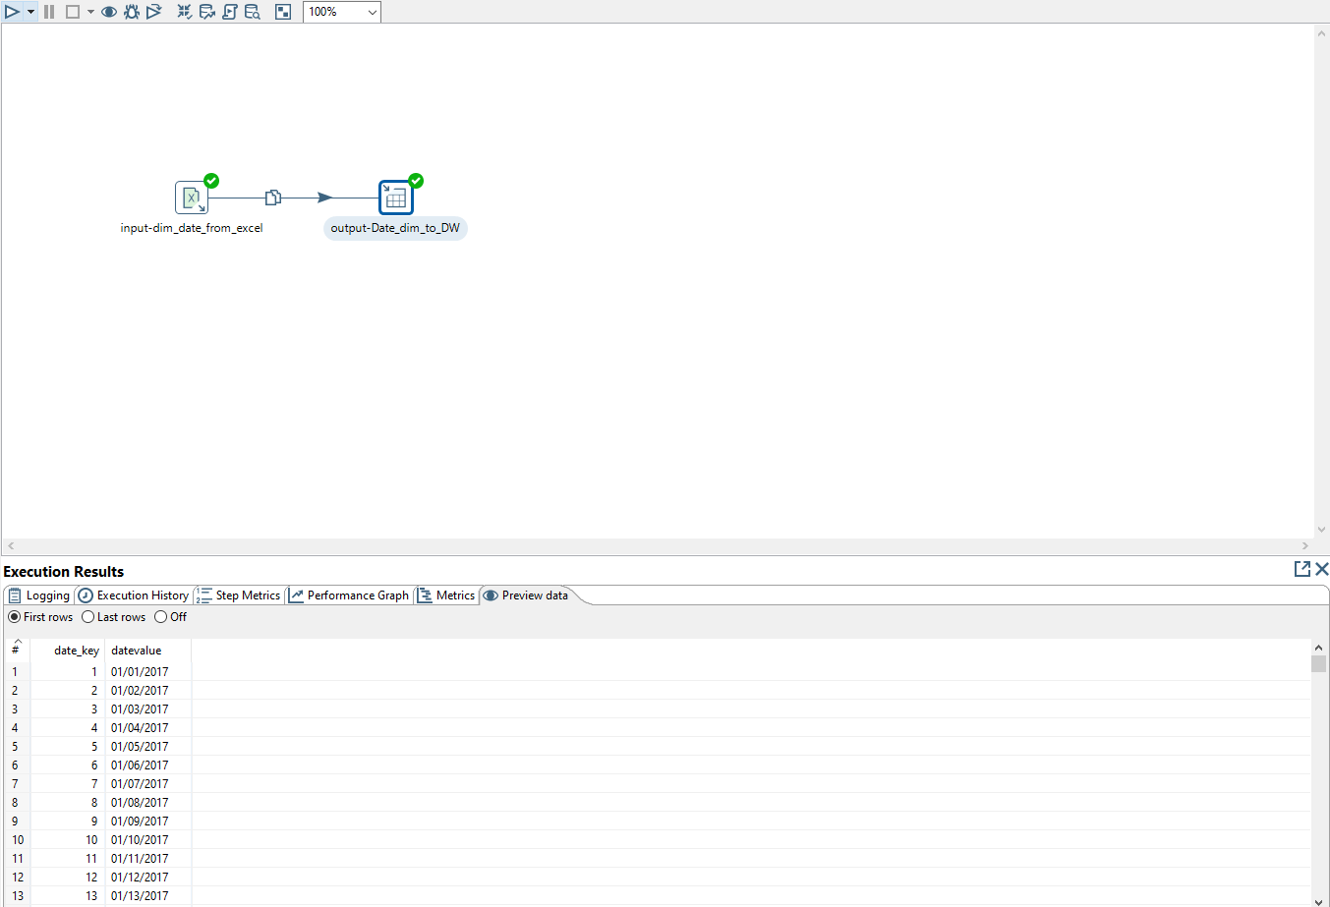

Mysql Results

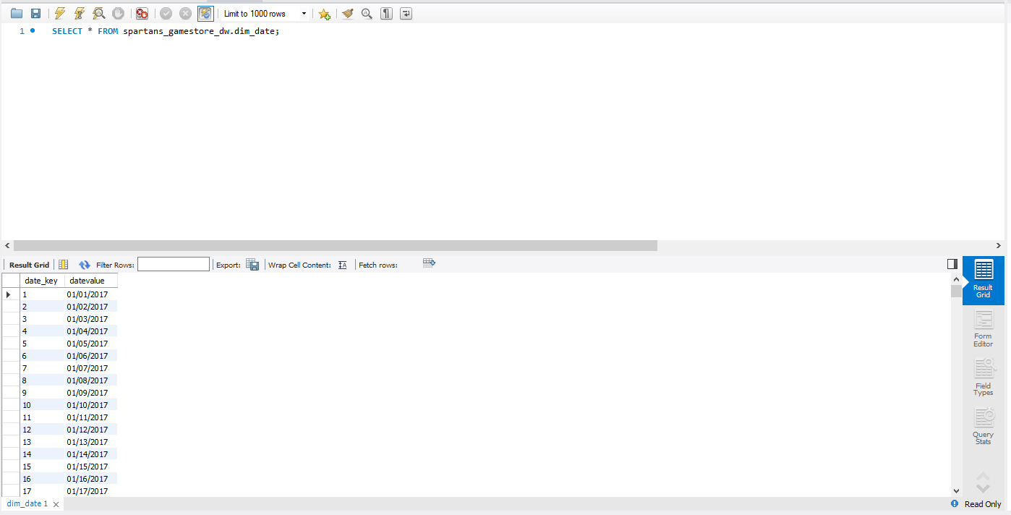

Order dimension data to Data Warehouse

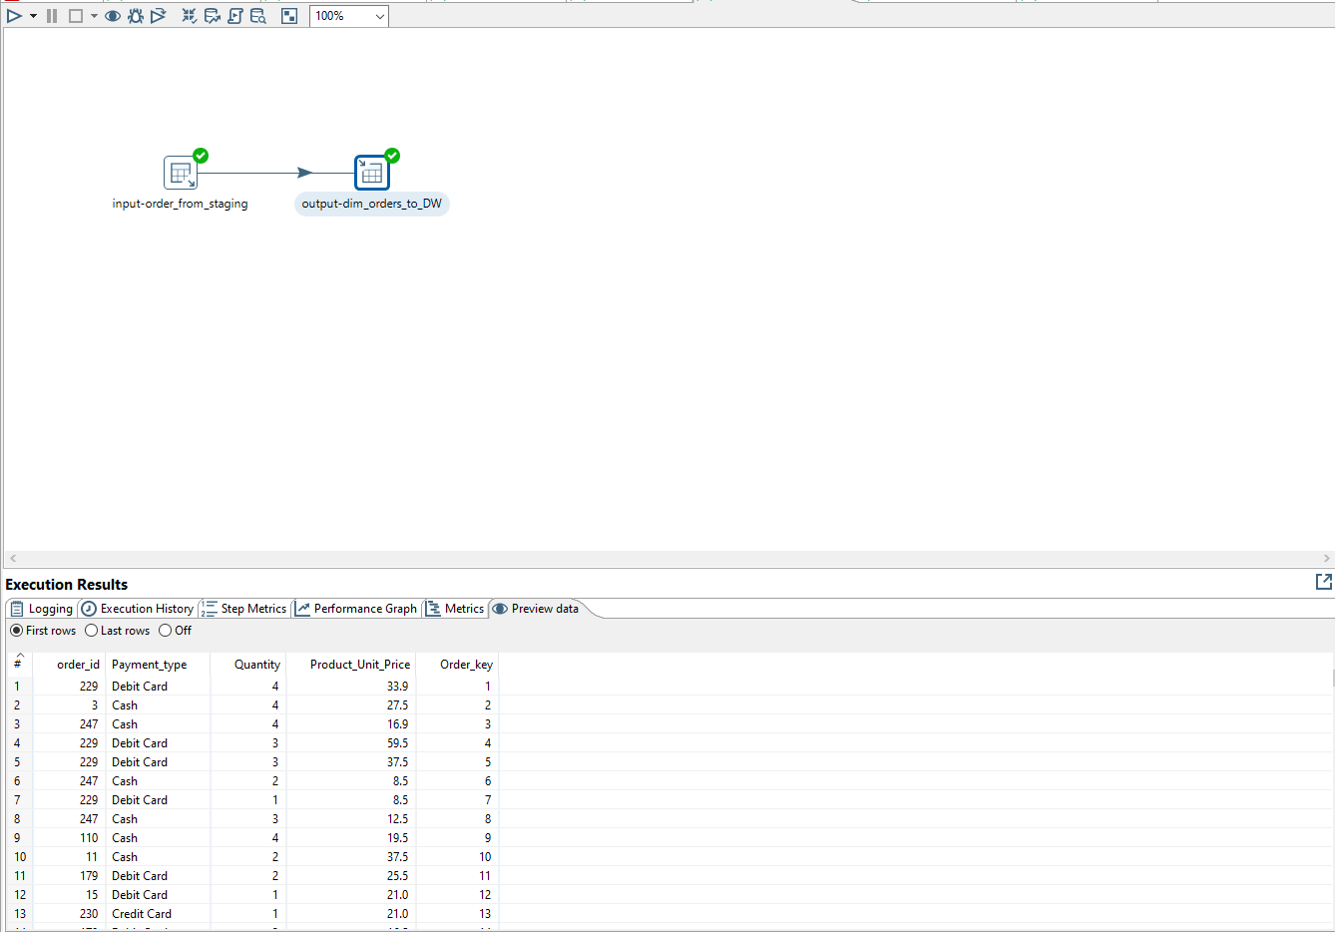

Mysql Results

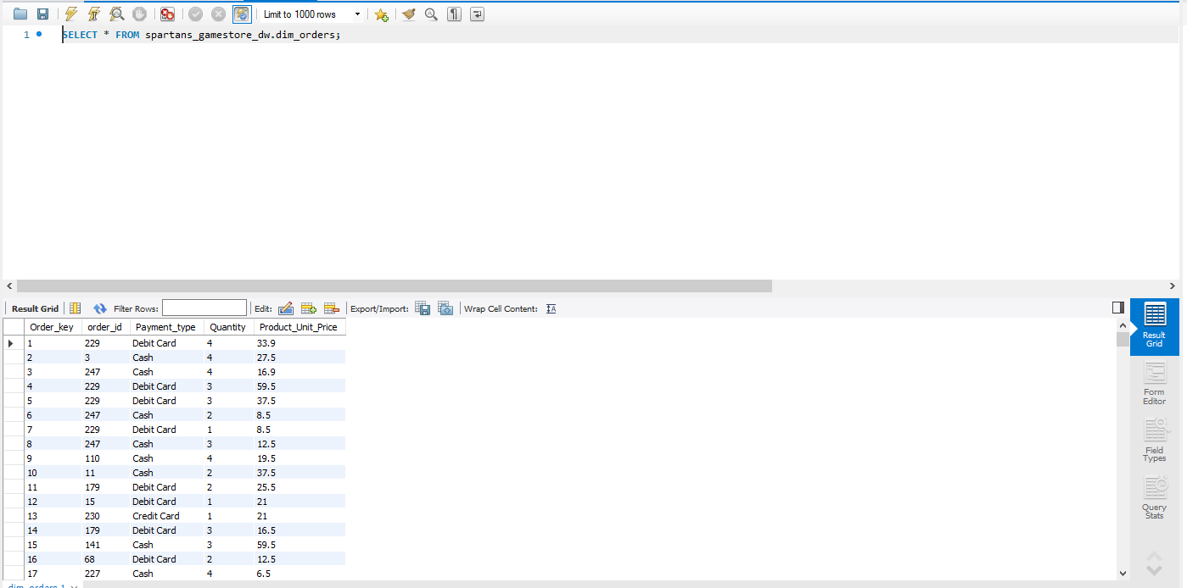

Product dimension data to Data Warehouse

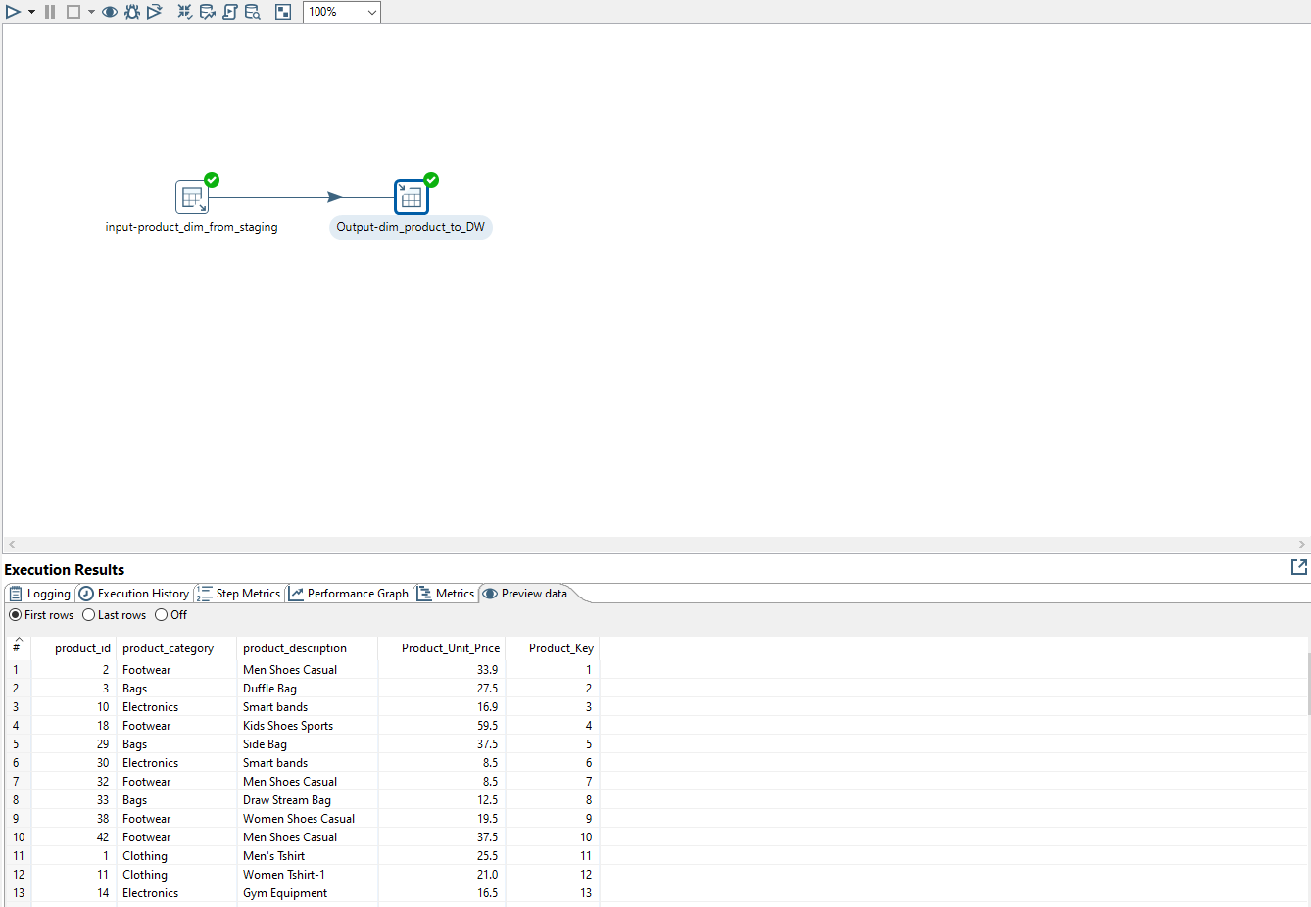

Mysql Results

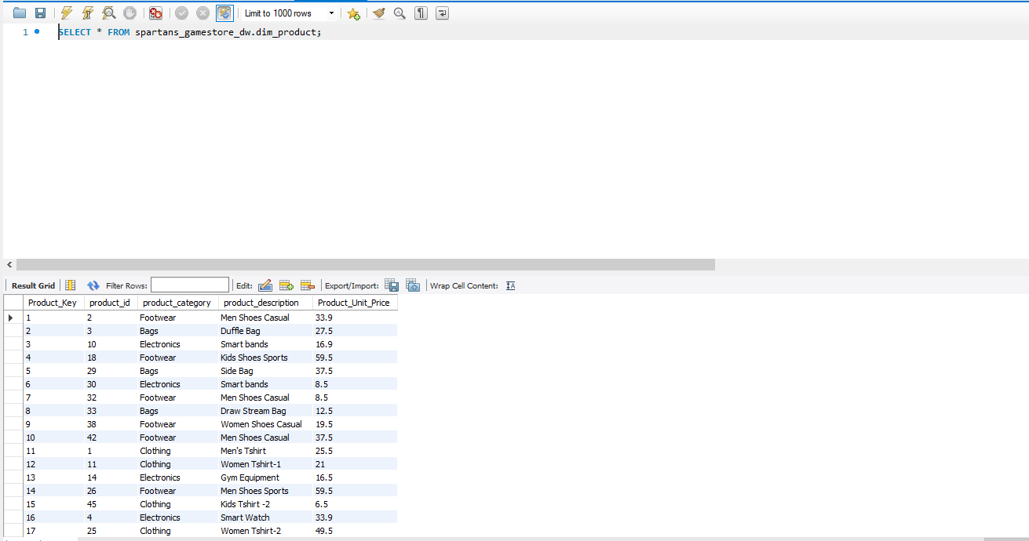

Store dimension data to Data Warehouse

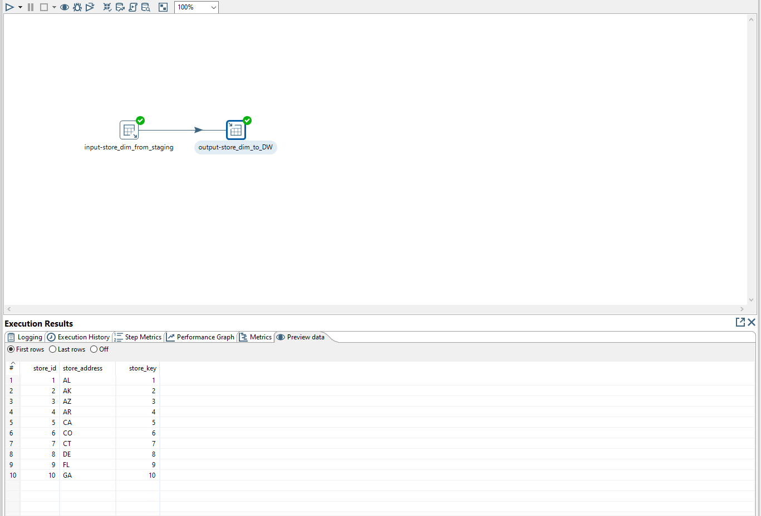

Mysql Results

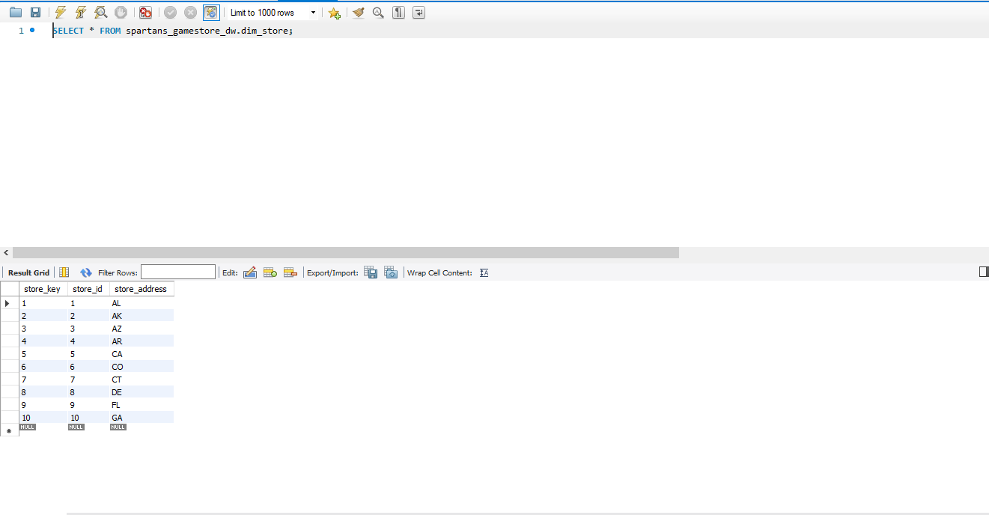

Sales Fact data to Data Warehouse

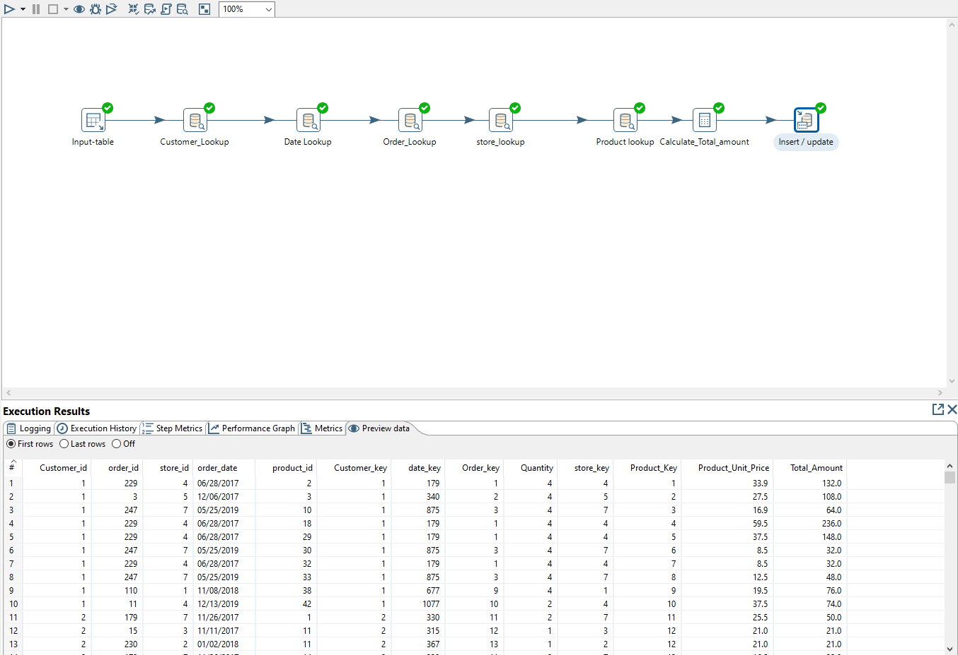

Mysql Results

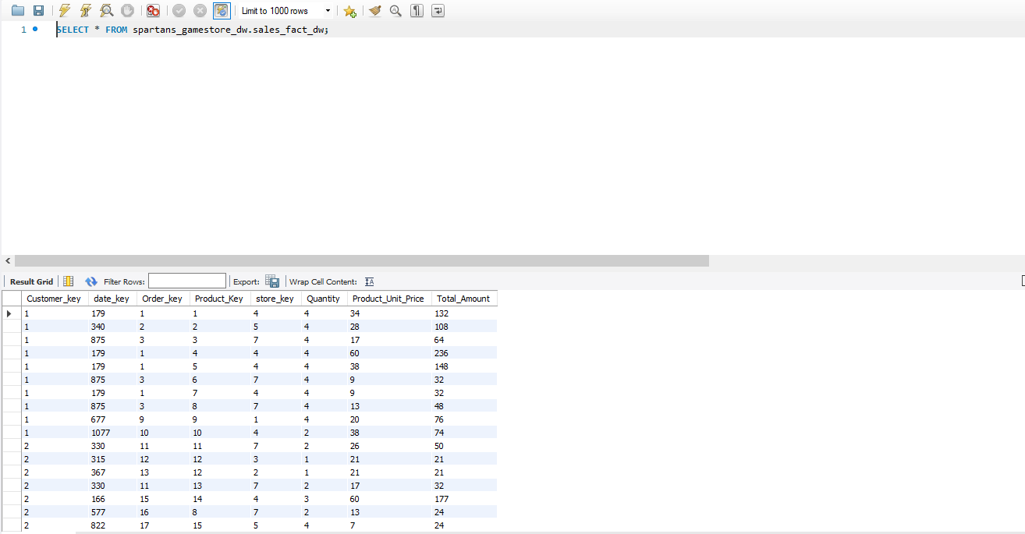

# Part- 4 Tableau Implementation

The Tableau file, has lead, lag, prescriptive and descriptive measures in a story. The main metrics which are highly insightful and impact the business decisions are taken and included in dashboards.

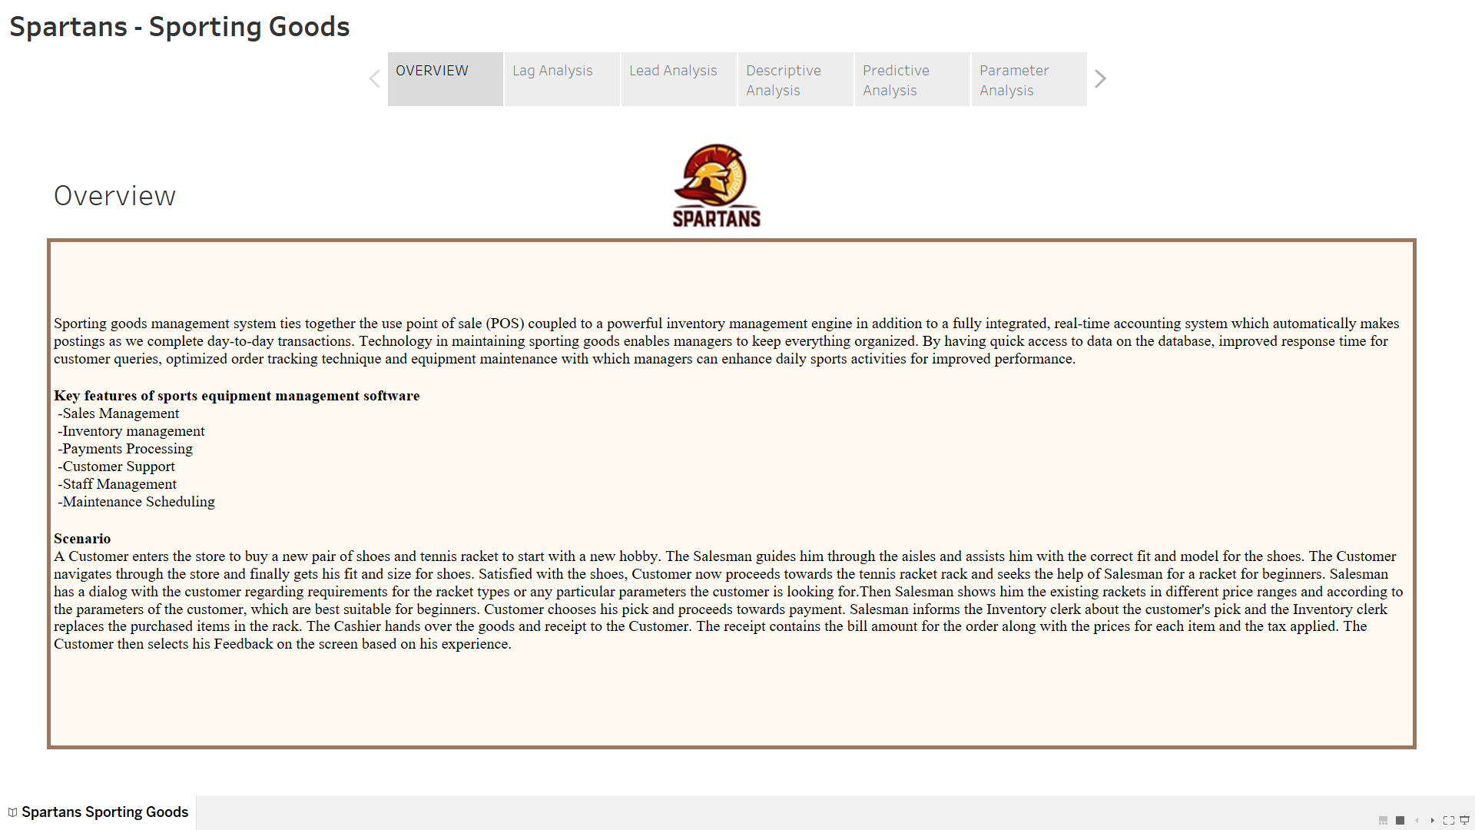

## **Dashboard 1 - Lag Measures:**

* + - 1. Revenue per store/per year
      2. Revenue each Quarter
      3. Average Orders per month
      4. Revenue each month

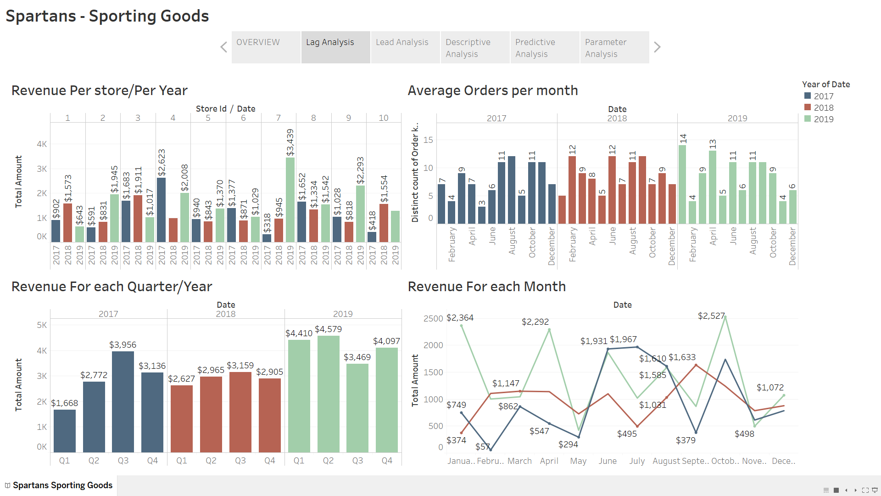

**Dashboard 2 - Lead Measures:**

Orders in week

Revenue per week

Product most sold in each weekday

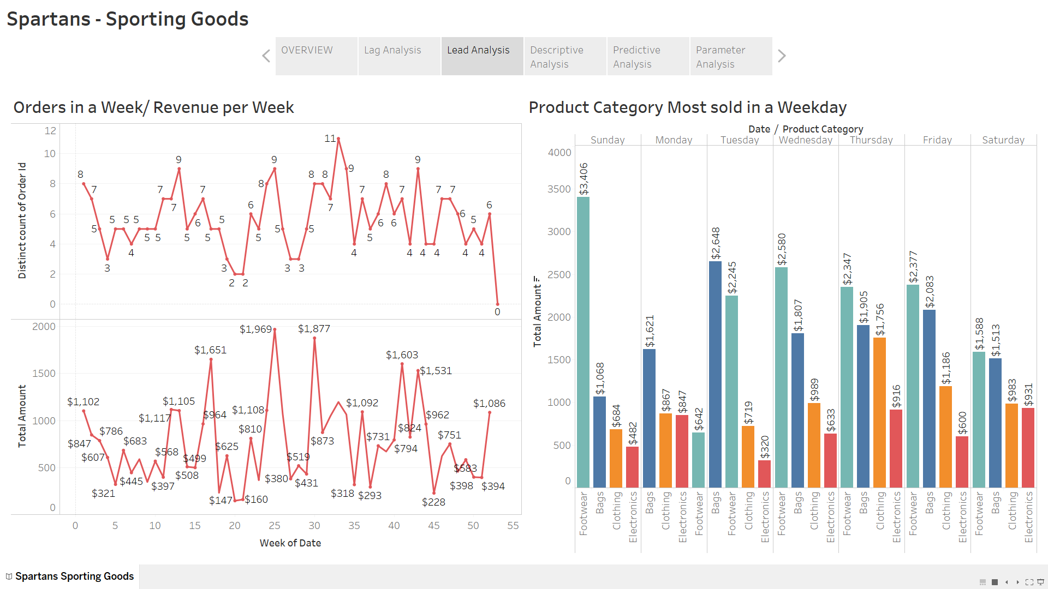**Dashboard 3 - Descriptive Analysis:**

1. Sales Vs Category
2. Age Vs category
3. Payment Type Analysis
4. State wise distribution

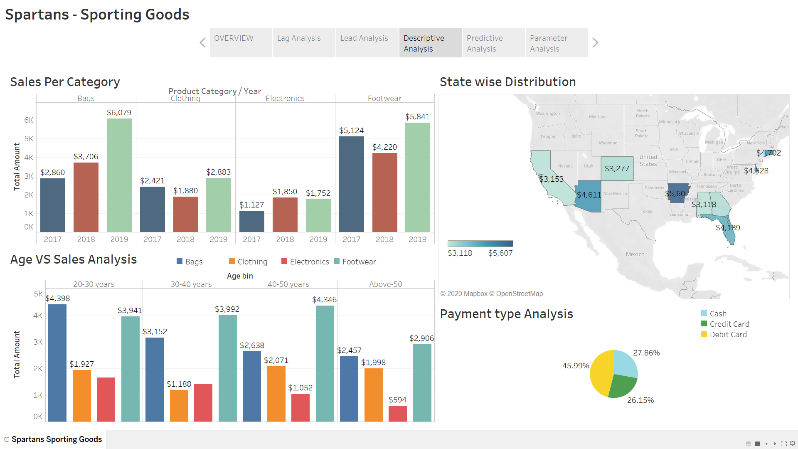

**Dashboard 4 – Predictive Analysis:**

1. Revenue Forecast
2. Demand Forecast

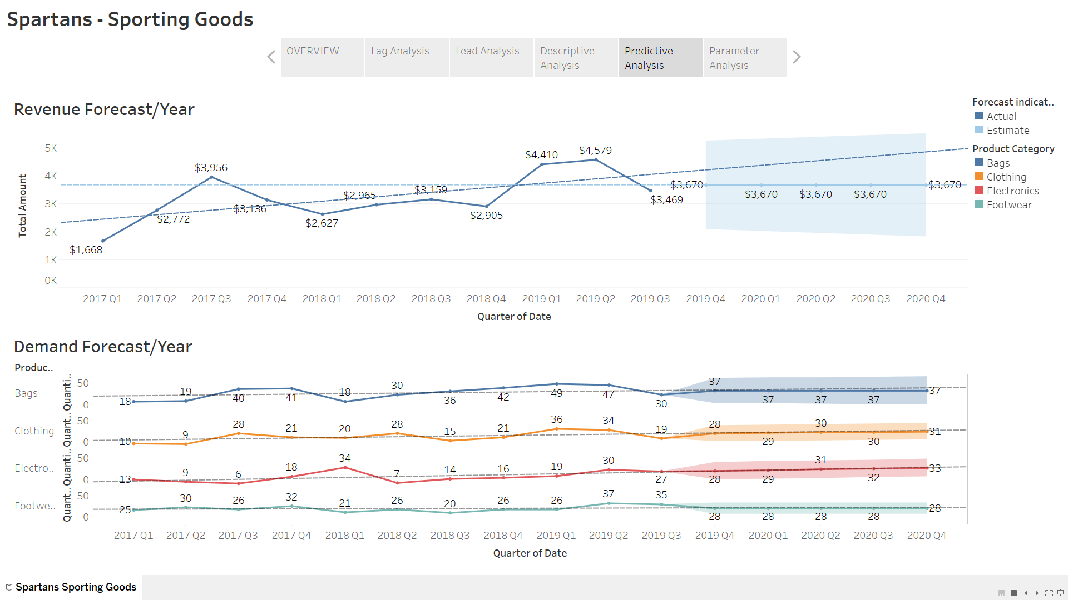

# Conclusion

In summary, BI makes it possible to combine data from multiple sources, analyze the information into a digested format, and then disseminate the information to relevant stakeholders. This allows companies to see the big picture and make smart business decisions.  By analyzing all these metrics and reports business can make critical decisions about the inventory, which stores are lucrative, which products need improvement, product unit price optimization.

**Key Learnings:**

1. Learn to use the language of the business and ask questions.
2. Know the audience, data, and right tools.
3. BI makes it easier for people to see and understand their data without the technical knowledge.
4. Without comparison values, numbers on a dashboard are meaningless for the users.
5. Having Single truth value across organization.

Link to tableau: <https://public.tableau.com/profile/ramya.mamidipaka#!/vizhome/Final_Submission/SpartansSportingGoods>